Content transformation

Normalization
The normalization process produces an internally used XML format of any input data format which is used to generate all target markup formats.
The normalized xml format looks like this.
<?xml version="1.0" encoding="utf-8"?>
<tree>
<page type="document-form">
<add_title></add_title>
<add_subtitle></add_subtitle>
<add_abstract></add_abstract>
</page>
<page datasource_id="typo3">
<title>Page Header</title>
<subtitle></subtitle>
<description></description>
<abstract></abstract>
<author></author>
<lastUpdated>01-05-2009</lastUpdated>
<plugin_9 datasource_id="typo3">
<header>
<h1>Content Header</h1>
</header>
<news datasource_id="typo3">
<news_title>News Title</news_title>
<news_short></news_short>
<news_text>
<p>DocBook is a semantic markup language for technical documentation. It was originally intended for writing technical documents related to computer hardware and software but it can be used for any other sort of documentation.</p>
</news_text>
<news_author></news_author>
</news>
</plugin_9>
</page>
</tree>

Target Document Markup

Transformation to DocBook
Internal XML | Docbook | Note
tree | article
page | section
title | title
subtitle | subtitle
author | -
text | n/a
pic | n/a
textpic | n/a
ttnews | n/a
tt_news | n/a
images | n/a | Special case text/mB see below
image | mediaobject
image/alias | imageobject/imagedata
image/caption | caption
header/h1-6 | para | with attribute class="header1-6"
h1-6 | para | with attribute class="header1-6"
table | informaltable/tgroup
thead | thead
tbody | tbody
tr | row
th | entry
td | entry
p | para
a | ulink
span | emphasis
strong | emphasis
i | emphasis
ul | itemizedlist
ol | orderedlist
li | listitem
blockquote | blockquote

Special cases
....
<bodytext>
<p>Blah</p>
</bodytext>
<images position="left">
<image>
<alias>Blah</alias>
<caption>Blah</caption>
</image>
</images>
....
Will be transformed into
....
<informaltable>
<tgroup cols="2">
<tbody>
<row>
<entry>
<mediaobject>
<imageobject>
<imagedata fileref="Blah" />
</imageobject>
<imageobject>
Blah
</caption>
</mediaobject>
</entry>
<entry>
<para>Blah</para>
</entry>
</row>
</tbody>
</tgroup>
</informaltable>
....
In the case of position="right" the two <entry> tags are switched

DocBook

This section gives an short overview about Docbook in relation to CMP3.
DocBook is a semantic markup language for technical documentation. It was originally intended for writing technical documents related to computer hardware and software but it can be used for any other sort of documentation.
Having the DocBook format a wide variety of output formats can be generated. The diagram below shows the possible transformation and rendering pipelines for DocBook.
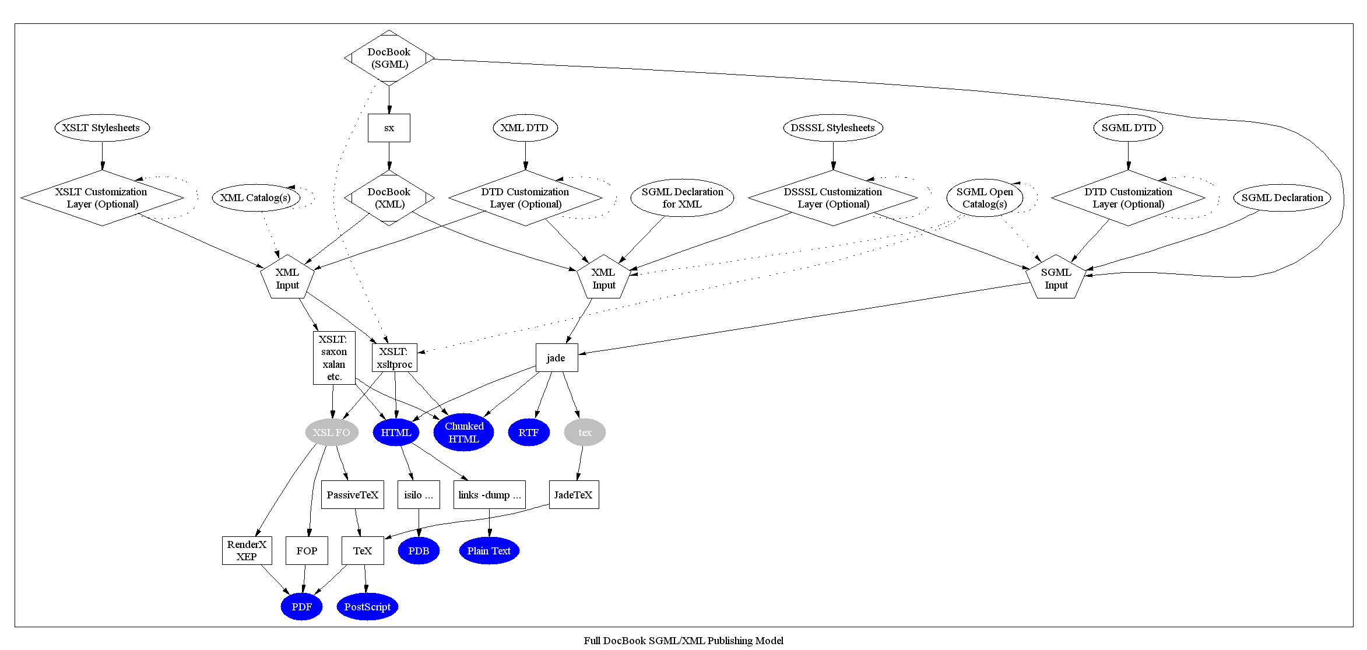

Limitations of DocBook
As a semantic language, DocBook enables its users to create document content in a presentation-neutral form that captures the logical structure of the content; that content can then be published in a variety of formats.
In relation to DocBook 'semantic' means that the documents elements are marked (markup) with tags to give the elements a meaning like header, paragraph or numbered list. That given it is clear that DocBook is meant to be used for structured documents.
For DocBook rendering (transformation) multiple solutions exists to create HTML, PDF and other formats. Because of the sematic markup which is targeted to structured documents the generated output is a structured document in all output formats.
That makes clear that DocBook might not be the right format for other document types like catalogs, mailings and so on. For specialized documents a direct transformation could be used instead of the intermediate DocBook format. On the other hand such a solution means to build a transformation from ground up and much more bigger task than customizing the DocBook transformation.

Comparison of markup
HTML | Docbook
<p> | <para>
<pre> | <computeroutput>, <programlisting>, <literallayout>
<ul> | <itemizedlist>
<ol> | <orderedlist>
<il> | <listitem>
<dl> | <variablelist>
<dt> | <term>
<dd> | <listitem>
<a href=""> | <ulink url="">
<code> | <literal>, <programlisting>
<strong> | <emphasis>
<em> | <emphasis>
" | <quote>

